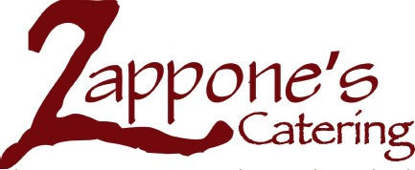
Field Day Lunch Friday, May 19th
Orders Due: Wednesday, May 17th
Lunch Options | Price | Quantity
Ham & Provolone Sandwich (Chips included) | $8.00
Turkey & Fresh Mozzarella Sandwich (Chips included) | $8.00
Veggie Wrap (Hummus, Provolone, tomatoes, lettuce, red peppers, onions) | $7.00
Large House Mixed Greens Salad with Red Wine Vinaigrette | $7.00
Add chicken to salad | $2.00

Student Name: ___________________________ Grade: _____

Teacher Classroom: _______________________

Kid Options | Price | Quantity
Kid’s Turkey & Provolone Sandwich | $5.00
Kid’s Ham and Cheese Sandwich | $5.00
Kid’s Veggie Wrap (provolone, cucumbers, tomatoes, lettuce) | $5.00
Special Requests/Allergies:

Order Forms are due to the office by Wednesday, May 17th

All orders include chocolate chip cannolis!

Total Amount Due: ________________

