Fly Me to the Moon, Let Me Play Amongst the Stars
Summer School Adventure
Explore the Wild Frontier of Space
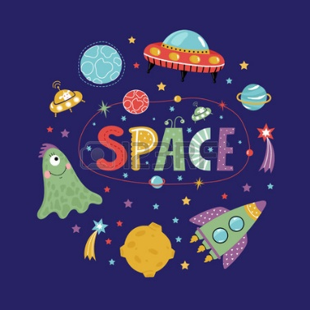
San Tan Charter School will be offering a summer program filled with exciting activities that take your students to outer space and beyond. Our focus will be on Space Science and Technology. Our summer school program will offer students the opportunity to experience various scientific discoveries through video, dance, art, storytelling, food, sports, math, science, history and other hands on activities. Each week we take different adventures to explore space travel and life on other planets:

Weeks 1-2 (June 4th – 15th): Important Space Scientists & the History of Space Travel
Weeks 3-4 (June 18th – 29th): Planet Earth, Moon, & Sun
Weeks 5 (July 2nd – 6th): Closed
Weeks 6-7 (July 9th – 20th) Student Choice Four Planets, History of NASA, Space Station
Weeks 8-9 (July 23rd – Aug 3rd): Create Your Own World (Field Trip to the Arizona Challenger Space Center TBD)
Students are free to sign-up for all or part of the program and are expected to bring their own lunch and snacks each day (no snacks are needed for Cooks in the Kitchen on Mondays).
Tentative Daily Schedule (Subject to Change)
8:20 – 9:50: Morning Recess
9:50 – 10:00: Set-up for the Day
10:00 – 10:30: Space Related Activities
10:30 – 11:30: Snack & Art (Mondays Cooks in the Kitchen; Fridays Science Friday)
11:30 – 12:00: Storytime
12:00 – 12:30: Gym Recess (TBD)
12:30 – 1:00: Lunch (TBD)
1:00 – 1:30: Math Activities (Odd Squad)
1:30 – 2:30: Hands on Activities
2:30 – 2:45 Classroom Clean-up
2:45 – 3:15: Ms. Frizzle’s Magic School Bus
3:15 – 3:25: Walk Down to Lobby

